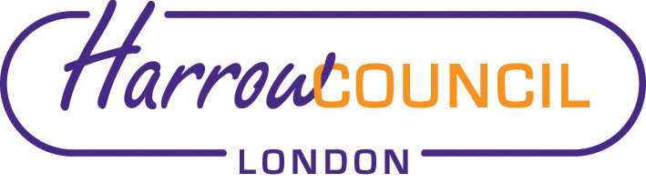
Harrow SACRE Meeting

Thursday 2 December 2021 at 7.30 p.m.
To be held via video conferencing

Enquiries & apologies to:
Vivian Wright, Clerk to SACRE
vmwright@waitrose.com

Adviser to SACRE: Lesley Prior

Agenda
- Welcome:

- Apologies for absence:

- Minutes of the last meeting on 28 September 2021 (attached): to agree the minutes as a true record.

- Matters arising from the minutes

- Local and National updates

- Collective Worship Policy

- Determinations
- Vaughan Determination

- Priorities for the year ahead
- Agreed Syllabus Conference

- Annual report for NASACRE

- News from Faith Groups relating to schools

- Any Other Business

- Future Dates
- Tuesday 8 March 2022 (already agreed)

Dates 2022-23: these dates have just been sent to us from the council and will be reviewed at the meeting: if you cannot attend the meeting and have a difficulty with any of these dates, please let Vivian know by 2 December as we need to confirm with the council.

- Tues 28 June 2022
- Wed 14 Sep 2022
- Tues 6 Dec 2022
- Wed 1 March 2023

